Year 2 Status Update: How are we going?
At the end of its second year, significant progress has been made towards progressing key actions under the Blueprint for Youth Justice in the ACT 2012-22.

Year 2 priorities:
Focus has been on:
strengthening prevention and diversion strategies
embedding initiatives and practices already underway
developing new policy and program work
Work undertaken includes:
Youth Justice Support & Intervention Framework
- - implementation phase
Family Engagement Strategy
- - implementation phase
Cultural planning
- - implementation phase
Youth Diversion Service
- - under development

Where are we up to?
Completed year 2 of the 10 year strategy and 3 year action plan
Of the 45 actions identified
in the action plan:
14 are complete
28 are substantially complete
3 are yet to commence.

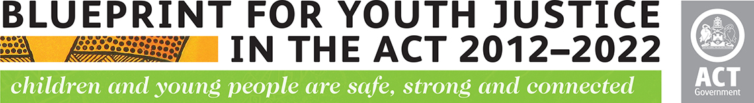
Year 2 Snapshot: Major Achievements¹
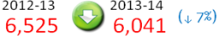
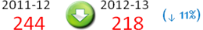
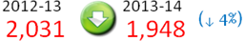
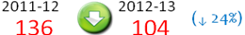
the number of young people apprehended
by ACT police
- - suggesting a decrease in the levels of offending

time young people spend in custody (days)
- - suggesting successful implementation of diversionary initiatives

the number of young people under
supervision
- - due to a decrease (16%) in first time supervisees

the number of young people in detention
- - suggesting successful implementation of diversionary initiatives

¹ ACT Criminal Justice Statistical Profile, June 2014 Quarter; AIHW Youth Justice in Australia 2012-13 (including supporting tables)

Demographic Snapshot²
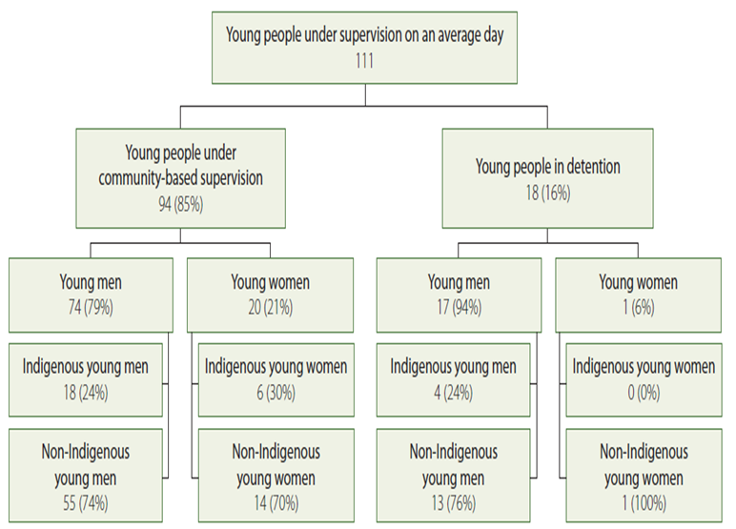
On an average day in 2012-13, young people under youth justice supervision in the ACT were:

² Youth Justice factsheet no 19, AIHW Youth Justice in Australia 2012-13, Table S134 a, b, c
Data snapshot: Youth justice four-year trends for the ACT

Key findings³:
- the number of young people coming to the attention of the justice system in the ACT is decreasing
- this reduction is consistent with similar reductions seen in the number of young people being placed under youth justice supervision.

³ Key findings and data tables sourced from: ACT Criminal Justice Statistical profile, June 2014 Quarter; AIHW Youth Justice in Australia 2012-13

From 2009-10 to 2012-13, there have been reductions in the number of young people:

Over-representation of Aboriginal and Torres Strait Islander young people

- being apprehended by ACT Policing ( 29%)

In the ACT, Aboriginal and Torres Strait Islander young people (10-17 years) constitute 2 per cent of the ACT population but form one-quarter (26%) of young people under youth justice supervision on an average day.

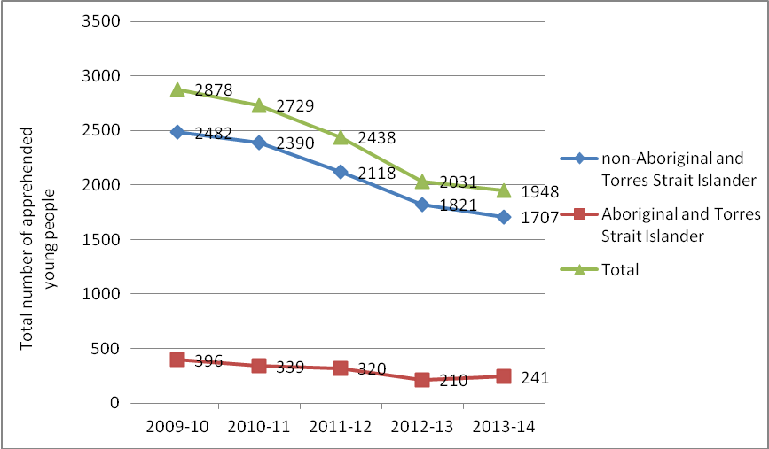

Since the commencement of the Blueprint, we are starting to make progress in addressing this over-representation.

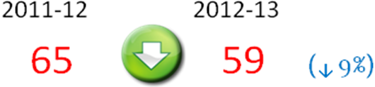
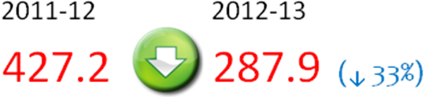
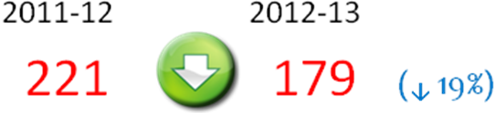
A one year data snapshot⁴ for Aboriginal and Torres Strait Islander young people shows reductions in:
the number of young people under supervision

the rate of young people under supervision on an average day (per 10,000)

the average length of time spent under supervision (days)

- under supervision during the year (22%)
- community-based supervision (19%)
- detention (40%)

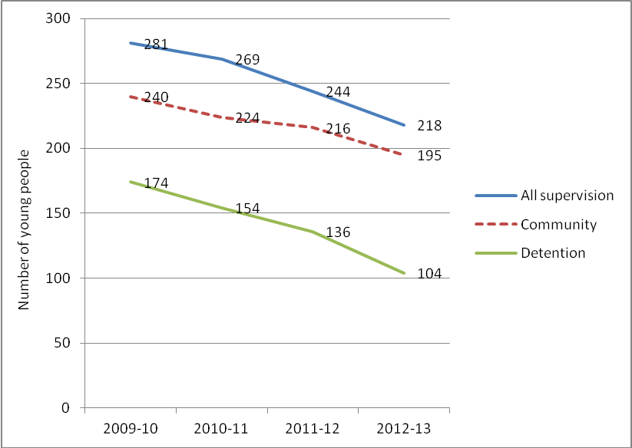

⁴ AIHW Youth Justice in Australia 2012-13 (including supporting tables)

In 2012-13:

In the ACT, an Aboriginal and Torres Strait Islander young person is 13 times as likely to be under youth justice supervision during the year as compared with a
non-Aboriginal and Torres Strait Islander young person.

This compares with the national level of over-representation of 17 times.

The ACT had one of the lowest levels of over-representation among all states and territories, where data was available.

- experiencing supervision for the first time (49%)

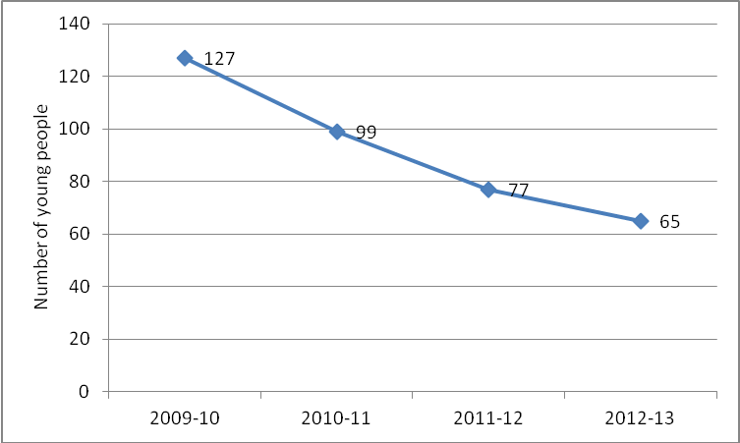

How do we compare nationally?

- In 2012-13, on an average day in the ACT, the rate of young people (10-17) under youth justice supervision was 27.7 per 10,000
- This was the third highest rate nationally across six reporting states (WA & NT were excluded)
- In the ACT, this rate has declined over the last four years from 29.7 to 27.7 per 10,000.

Data sourced from: AIHW Youth Justice in Australia 2012-13, pp 5 & 16

The figure below provides a snapshot of the number of young people under supervision in the ACT, compared with national levels.

It shows the ACT has similar percentages of young people involved with the youth justice system, when compared with national levels.
Group conferencing (restorative justice)
Recent data⁵ shows a decline in the number of young people being referred to and successfully completing group conferencing.

In 2012-13 to 2013-14:
- the total number of young people referred to group conferences decreased (43%)

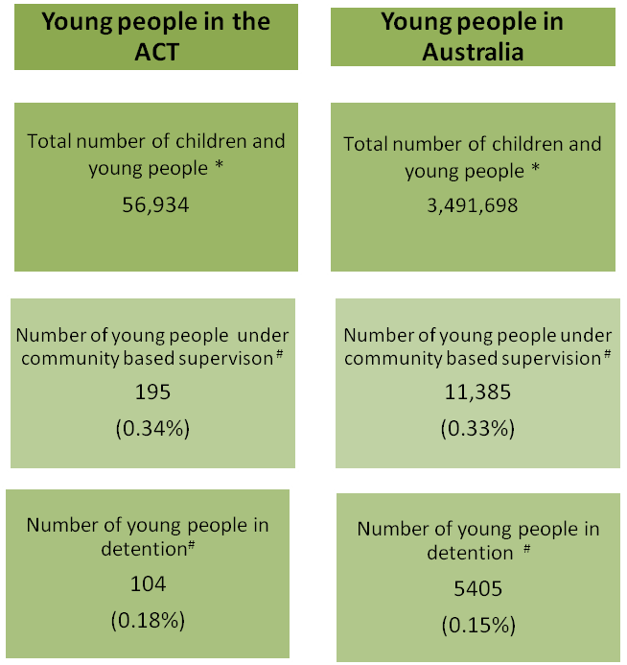
* Source: ABS Population by age and sex tables, table 8 (Estimated resident population, by age and sex, at 30 June 2013, released 19 June 2014)
# Source: AIHW Youth Justice in Australia 2012-13, Tables S46b, S72b

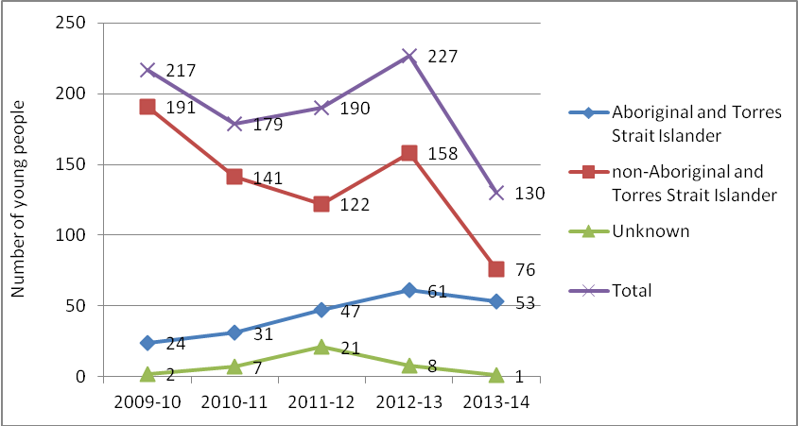

In 2011-12 to 2012-13:
- the number of group conferences involving young people resulting in an agreement decreased (16%)

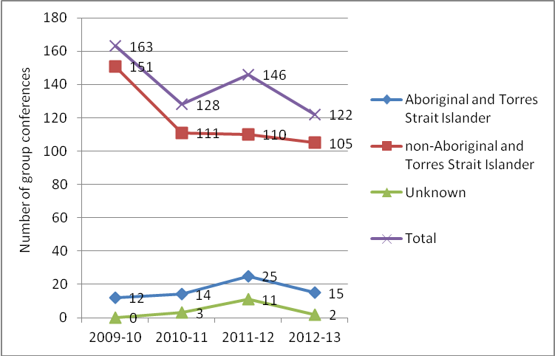

Where are we headed?
Our first priority is to continue to strengthen prevention & diversion strategies.

Youth Diversion Service

In partnership with Child, Youth and Family Services Program, the service will provide early intervention and prevention responses for young people and their families by targeting young people in their early stages of contact with the justice system.
The service will connect young people and their families with the supports they need, when they need them to minimise the risk of ongoing statutory service involvement.

Declines may be attributable to:
- ongoing reductions in the number of apprehensions of young people by ACT Policing
- a re-adjustment to the rate of referrals following the Restorative Justice trial initiative

⁵ ACT Criminal Justice Statistical profile, June 2014 Quarter; Report on Government Services (ROGS) 2014, Chapter 16 Youth Justice Services

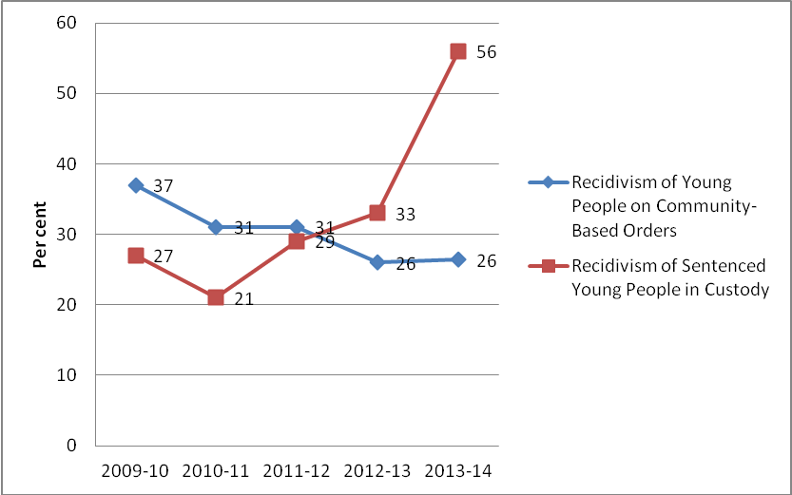
⁶ Community Services Directorate Quarterly Reports, Output 4.1, Unpublished data: 2013-14 CSD Quarterly Report, 4th Quarter YTD results
Where are we headed?

Priorities for 2014-15:

The third year of the implementation of the Blueprint will begin to see a shift of focus from consolidating changes to policy and practice in the areas of prevention and diversion to:
- embedding and making operational policy and practice change-initiatives through the Case Management and Support (MPower) working and operational groups
- supporting high-risk young offenders with complex needs who enter and remain in the youth justice system
- reducing over-representation of Aboriginal and Torres Strait Islander young people in the justice system
- focusing on early intervention initiatives including implementation of the Out of Home Care Strategy 2015-20
High-risk young offenders:
In the ACT, recent recidivism (re-offending) data⁶ suggests that detention is increasingly targeting young people with a more serious and/or repeat offending history.

This has been demonstrated over a five-year period (2009-10 to 2013-14) by a:
- decline in the rate of recidivism for young people on community-based orders
(11 percentage points)
- increase in the rate of recidivism for young people on sentenced detention orders
(29 percentage points)
These young people tend to be high-risk, with complex needs, requiring wrap-around and intensive service provision.

This is consistent with youth offending nationally, in that a very small proportion of young offenders are often responsible for most of the offending.

Research indicates that young people assessed as higher-risk offenders benefit most from intensive rehabilitative interventions, and that the intensity of services should be proportional to the young person’s level of risk.
Actions to commence
- 1.4 - Establish a shared understanding and co-ordinated actions across the government and the community to implement evidence-based programs to address behavioural disorders in children aged 5-12 years.

- 2.6 - Strengthen therapeutic programs for young people on community and detention orders.

- 3.4 - Develop collaborative service approaches to support young people and families with culturally and linguistically diverse backgrounds.
Work already commenced in this area:
- Youth Justice Support & Intervention Framework (Developed 2014. Make operational 2014/15)
The framework supports the delivery of targeted interventions & supports based on the assessed risk-level of young people.

- Strengthen practice alignment between Youth Justice and Turnaround (Practice reviewed 2014. Ongoing practice review and make operational in 2014/15)
Practice alignment reviewed and developed as part of the Integrated Management System project to ensure targeted case management and support services to high-risk young people with complex needs involved in the justice system.

Work to be commenced:
- Strengthen the integration between Youth Justice and Care and Protection Services
Particularly for children and young people who are known to have experienced trauma, abuse and neglect and those who are repeat offenders.

- Progress remaining actions (below)

Integration of Statutory Services in the ACT

The ACT is undertaking a Integrated Statutory Services (ISS) project to examine how to combine some or all of the activities performed in the Youth Justice and Care and Protection Services areas. This includes:
- reviewing processes and systems to remove duplication and unnecessary steps
- reviewing how to work with clients to reduce the number of people a child or young person needs to deal with
- implementing an integrated single case management approach
- implementing an organisational structure that encourages collaboration and information sharing.

The project is being delivered in four phases. To date, the focus has been on establishing the project, developing the project plan, current state analysis and developing high level design options. Outputs from the initial phase include agreed design principles, an integrated operating model and functional descriptions.

The ACT is now in the detailed design phase (phase 2) which includes:
- developing a single case management approach across Care and Protection and Youth Services, building on the successes of the YJ single case management model, and
- developing a detailed organisation design that includes consideration of the processes, roles and structures required to deliver better outcomes for children and young people.

It is expected that the project will progress through the various stages and be fully implemented by July 2015.

